Wunion.DataAdapter.NetCore
developers document

Lightweight database Query component library that encapsulates different kinds of database SQL commands in the form of C# object structure. This allows developers to focus more on the implementation of business code without having to care about the direct impact of different types of database command differences on the code. The component library is designed with the .NET Standard 2.0 Cross-platform standard, and supports the .NET Framework 4.6.2 above and the .NET Core 2.0 version of the various .NET applications. Leverages the cross-platform features of .NET Core to make this component library run on Windows, Mac OS X, and Linux systems.

The project is completely free of charge and the copyright of the component library is owned by the developer. Any enterprise or individual is free to use, but prohibits any enterprise or individual other than the developer from incorporating the component into its intellectual property in any form. Any commercial loss or interest dispute arising out of the use of the component shall be borne by the user at his or her own expense.

Development IDE: Microsoft Visual Studio 2017
Development language: C#
Target framework: .NET Standard 2.x
Library Name: Wunion.DataAdapter.NetCore
Root namespace: Wunion.DataAdapter.Kernel

Chapter I: Description of the package structure for the project
- Wunion.DataAdapter.NetCore -- The main project, the core implementation layer of SQL object.
- Wunion.DataAdapter.NetCore.SQLServer -- Microsft SQL Server 2008 R2 SP3 and the above version of the database support package.
- Wunion.DataAdapter.NetCore.SQLite3 -- The support package for the SQLite database.
- Wunion.DataAdapter.NetCore.MySQL -- The MySQL database support package (tested and passed in Mariadb 10.2).
- Wunion.DataAdapter.NetCore.PostgreSQL -- The PostgreSQL database support package (tested and passed in PostgreSQL 10).
- Wunion.DataAdapter.NetCore.EntityUtils -- Database Entity Model support package (with Entity Model Code Builder tool).

Chapter II: Querying database using Wunion.DataAdapter.NetCore

2.1： Classes that you must understand by using the component library

2.1.1: DataEngine class
This class provides access to the target database for insert/deleted/modified/query operations, as well as transaction management. An object instance of a DataEngine class is always associated with a specific type of database engine, and the class also provides static cache pool management capabilities for multiple DataeEgine instances.
Initializes an instance of the Dataengine engine: Creates an instance through a public constructor. The first parameter dba is an abstract DbAccess class that represents the accessor of the target type database, implemented by various specific database support packages for the component library (such as SqlServerDbAccess or NpgsqlDbAccess, etc.) The second parameter, ParserAdapter, is the interpreter adapter for the DbCommandBuilder Command object tree, which is also implemented by various specific database support packages for the component library.
AppendDataEngine static method: This method creates an instance of the DataEngine in the static cache pool, with the first two arguments consistent with the constructor, and the third parameter represents the key name of the DataEngine instance in the cache and defaults to "Default".
GetEngine static method: Gets an instance of the DataEngine for the specified key in the cache pool, where multiple database interactions can be easily implemented using a caching pool when a variety of databases are used simultaneously in one application.
RemoveEngine static method: Deletes the DataEngine with the specified key name from the static cache pool.
CurrentEngine static property: This property return the DataEngine instance of the default (that is: key name is "Default") in the static cache pool.

2.1.2：DbCommandBuilder class
The object tree used to build SQL commands, which provides object tree building methods for general SQL commands such as SELECT, INSERT, UPDATE, and DELETE, and supports an infinite level of nested queries. Stored procedures cannot be built using the DbCommandBuilder class. When executing a command using DataEngine, the object of that type is used as a parameter, and the DbCommandBuilder object tree is interpreted internally as the SQL command for the target database and executed.

2.1.3: Static class td, exp, fm and Fun
- td Create a field element in a command.
- exp Create an expression element in a command, and a LIKE clause element (most of which has been completed by the operator overload, and do not need to call the shortcut class manually).
- fm Create table elements and LEFT JION elements in a command.
- Fun Create a function element in a command.

2.2: Referencing and initializing component libraries
NuGet Package Reference:
- Wunion.DataAdapter.NetCore Core library (must be referenced)
Namespace: Wunion.DataAdapter.Kernel
Wunion.DataAdapter.Kernel.DbInterop
Wunion.DataAdapter.Kernel.CommandBuilders
- Wunion.DataAdapter.NetCore.SQLServer Microsoft SQL Server database support package (referenced on-demand)
Namespace: Wunion.DataAdapter.Kernel.SQLServer
Wunion.DataAdapter.Kernel.SQLServer.CommandParser
- Wunion.DataAdapter.NetCore.SQLite3 SQLite database support package (referenced on-demand)
Namespace: Wunion.DataAdapter.Kernel.SQLite3
Wunion.DataAdapter.Kernel.SQLite3.CommandParser
- Wunion.DataAdapter.NetCore.PostgreSQL PostgreSQL database support package (referenced on-demand)
Namespace: Wunion.DataAdapter.Kernel.PostgreSQL
Wunion.DataAdapter.Kernel.PostgreSQL.CommandParser
- Wunion.DataAdapter.NetCore.MySQL MySQL database support package (referenced on-demand)
Namespace: Wunion.DataAdapter.Kernel.MySQL
Wunion.DataAdapter.Kernel.MySQL.CommandParser

Initializing DataEngine: The associated namespace is introduced using a reference to the NuGet package, and the initialized Code as follows:
SqlServerDbAccess DBA = new SqlServerDbAccess();
DBA.ConnectionString = “Server=(local);Database=test;User ID=sa;Password=******”;
DataEngine.AppendDataEngine(DBA, new SqlServerParserAdapter()); // Add as Default Engine

The previous example uses the static cache provided by DataEngine class to globally instantiate. To freely define the global DataEngine instance if not used this idea.

2.3: Syntax for data query
In all of the sample code in this chapter, DataEngine.CurrentEngine represents a default DataEngine instance in static cache provided by DataEngine class. When the actual project uses other means to the global DataEngine instance, please use the concrete DataEngine instance.
DataEngine provides ExecuteQuery, ExecuteQuery<DataTable>, ExecuteReader, and ExecuteScalar four methods for querying the data to respond to the query requirements of different scenarios respectively. When an error occurs during the execution of the query, the above four methods return null, and the error message and the target SQL command that caused the error are provided in the DataEngine.DBA.Error property to provide a reference for debugging.

2.3.1: Single-Table Query
DbCommandBuilder Command = new DbCommandBuilder();
Command.Select(td.Field("Field1"), td.Field("Field2"))
.From("TableName")
.Where(td.Field("Field1") == 123 & td.Field("Field3") == true);
SpeedDataTable dt = DataEngine.CurrentEngine.ExecuteQuery(Command);
// To query all fields, use: td.Field("*")

Complex queries and their conditions: for example, the following SQL command.
SELECT *, [Num] * [Price] AS Total FROM [Products] WHERE [Selling] = true AND [Price] BETWEEN 100 AND 998

DbCommandBuilder implementation methods are as follows:
DbCommandBuilder Command = new DbCommandBuilder();
Command.Select(td.Field(“*”), (td.Field(“Num”) * td.Field(“Price”)).As(“Total”))
.From(“Products”)
.Where(
td.Field(“Selling”) == true &
Fun.BetweenAnd(td.Field(“Price”), 100, 998)
);
Element precedence groupings in the Command object tree: Understand what priority grouping is from the following SQL command
SELECT ([Field1] + [Field2]) * [Field3]
FROM [TableName]
WHERE [Field5] = FALSE AND ([Field4] IS NULL OR LEN([Field4] < 1))

The addition operation priority in the arithmetic expression in the SELECT, implemented on the DbCommandBuilder as follows:
(td.Field(“Field1”) + td.Field(“Field2”)).Group * td.Field(“Field3”)

The query result is incorrect if the logical operation expression in the Where condition is not grouped. The priority grouping implementation of logical operations is similar to arithmetic, implemented one the DbCommandBuilder as follows:

td.Field(“Field5”) == false & (td.Field(“Field4”).IsNull() | Fun.Len(td.Field(“Field4”)) < 1).Group

2.3.2: Multi-Table Query
DbCommandBuilder Command = new DbCommandBuilder();
Command.Select(td.Field("t2", "TestId"), // using : td. Field ( "t2", "*")
td.Field("t1", "GroupName"), // to Query the all fields of one table.
td.Field("t2", "TestName"),
td.Field("t2", "TestAge"),
td.Field("t2", "TestSex"))
.From(fm.Table("DATA_TABLE", "t2"),
fm.LeftJoin("GROUP_TABLE", "t1")
.ON(td.Field("t2", "GroupId") == td.Field("t1", "GroupId"))
)
.Where(td.Field("t2", "GroupId") == groupId)
.Paging(pageSize, currentPage, td.Field("t2", "TestId"), OrderByMode.DESC); //Working with paging features
SpeedDataTable dt = DataEngine.CurrentEngine.ExecuteQuery(Command);

When you make paging available one the Microsoft SQL Server database, you must use ORDER BY for the query, which is not required for other databases. Multiple-table queries support only the LEFT JOIN method, and not supported RIGHT JOIN. Compound expressions, priority groupings, etc. are described in the chapter 2.3.1

2.3.3: Nested queries
DbCommandBuilder Command = new DbCommandBuilder();
Command.Select(td.Field(“*”)).From(“DATA_TABLE”)
.Where(td.Field(“GroupId”).In(
Command.Nested(td.Field(“GroupId”)).From(“GROUP_TABLE”)
.Where(td.Field(“GroupName”).Like(“test”, LikeMatch.Center))
) & td.Field(“TestSex”) >= 18
);
SpeedDataTable dt = DataEngine.CurrentEngine.ExecuteQuery(Command);

2.4: Records -- INSERT/UPDATE/DELETE
Record's insert, update, and delete to execute a command by invoke the ExecuteNoneQuery method of the DataEngine instance. When an error occurs during the execution of a command, the method return -1. and provides the error message and the target SQL command in the DataEngine.DBA.Error property for debugging.

2.4.1: Insert record
DbCommandBuilder Command = new DbCommandBuilder();
Command.Insert("DATA_TABLE", td.Field("GroupId"), td.Field("TestName"), td.Field("TestAge"))
.Values(2, "The test name.", 12.3f);
int result = DataEngine.CurrentEngine.ExecuteNoneQuery(Command);
// Get the value of an identity field after inserted.
int TestId = Convert.ToInt32(DataEngine.CurrentEngine.DBA.SCOPE_IDENTITY);

2.4.2: Update record
DbCommandBuilder Command = new DbCommandBuilder();
Command.Update("DATA_TABLE")
.Set(td.Field("TestName") == NewName, td.Field("TestAge") == Age)
.Where(td.Field("TestId") == Id);
int result = DataEngine.CurrentEngine.ExecuteNoneQuery(Command);

2.4.3: Delete record
DbCommandBuilder Command = new DbCommandBuilder();
Command.Delete("DATA_TABLE")
.Where(td.Field("TestId") == Id & td.Field("GroupId") == GrpId);
int result = DataEngine.CurrentEngine.ExecuteNoneQuery(Command);

2.5: Use the QuickDataChanger shortcut class
You can use this class to build insert, update, and delete command without DbCommandBuilder, and that class provides a way to batch update SpeedDataTable and DataTable to the database.
Namespace: Wunion.DataAdapter.Kernel

Insert, Update and Delete
The insert and update record is made by invoke the Quickdatachanger.SaveToDataBase method, which define as follows
public int SaveToDataBase(string TableName, Dictionary<string, object> data, bool executeUpdate)
Parameters:
TableName Table name (in the database)
data A dictionary collection of fields and their values that are updating or inserting.
executeUpdate True when the updating, False for inserting.
When an update or delete operation is performed, the conditions is specified by Conditions property of the instance of QuickDataChanger.
The following code demonstrates updating data to a record, attempting an insert operation if the update fails, or incorrect incoming data if the insert operation still fails.

QuickDataChanger DC = new QuickDataChanger();
DC. Conditions.Add(td.Field(“TestId”) == TestId & td.Field(“GroupId”) == GroupId);
int result = DC.SaveToDataBase("DATA_TABLE", Data, true);
if (result < 1)
{
DC. Conditions.Clear(); // The condition of the update should be cleared when the insert operation is performed
result = DC.SaveToDataBase("DATA_TABLE", Data, false);
}
// If the value of result at this time is still less than 1, then the incoming data is incorrect.
// Deleting records invoke the DC.Delete method, as follows:
// result = DC.Delete(“DATA_TABLE”);

Bulk update of data collection
The mechanism for batch updating needs to be defined itself, and the following code assumes that the "STATE" column is defined in the speedTable to represent the status information for each row of data, and invoke the BatchSaveDataTable method to use this rule to bulk update the data collection to the database.
A batch update should be performed in a transaction to increase it’s execution efficiency and rollback control of the operation, it's bad for the performance if not performed in a transaction.

QuickDataChanger DC = new QuickDataChanger(trans);
int result = DC.BatchSaveDataTable(speedTable, (SpeedDataRow Row) => {
DataRowSubmission RowSubmission = null;
switch (Row.Field<int>("STATE"))
{
case 1:
RowSubmission = new DataRowSubmission(QuickDataChangerSubmission.Update);
RowSubmission.NotInsertFields = new string[] { "TestId" }; // Do not update field TestId.
RowSubmission.Conditions.Add(td.Field("TestId") == Row.Field<int>("TestId")); //Set update condition
break;
case 2:
RowSubmission = new DataRowSubmission(QuickDataChangerSubmission.Insert);
RowSubmission.NotInsertFields = new string[] { "TestId" }; //Do net insert field TestId.
break;
case 3:
RowSubmission = new DataRowSubmission(QuickDataChangerSubmission.Delete);
// Set delete conditions
RowSubmission.Conditions.AddRange(new object[] {
td.Field("TestId") == Row.Field<int>("TestId") &
td.Field("GroupId") == Row.Field<int>("GroupId")
});
break;
default:
RowSubmission = new DataRowSubmission(QuickDataChangerSubmission.Ignore);
break;
}
return RowSubmission;
});
trans.Commit();
trans.Dispose();

2.6: Use transaction
Use the BeginTrans() method of the DataEngine instance to start a transaction and return a controller object of the DBTransactionController type, DBTransactionController class is located in the Wunion.DataAdapter.Kernel.DbInterop namespace.

Executing command in a transaction
When executing commands in a transaction, you should use the DBTransactionController.DBA.ExecuteNoneQuery method, instead of the ExecuteNoneQuery method of the DataEngine instance. The following sample code:

using (DBTransactionController trans = DataEngine.CurrentEngine.BeginTrans())
{
trans.DBA.ExecuteNoneQuery(Command);
trans.Commit();
}

The object of the QuickCataChanger controlled by transaction
Example:
int result = -1;
using (DBTransactionController trans = DataEngine.CurrentEngine.BeginTrans())
{
QuickDataChanger DC = new QuickDataChanger(trans);
DC.Conditions.Add(td.Field("GroupId") == GrpId);
DC.Delete("DATA_TABLE");
DC.Conditions.Clear();
DC.Conditions.Add(td.Field("Id") == GrpId);
result = DC.Delete("GROUP_TABLE");
if (result > 0)
trans.Commit(); // Commit transaction when a group deletion succeeds.
}

A transaction must be freed after it has been used. Code in the scope of the transaction control should use Try...catch for error handling, and When an exception occurs should invoke the transaction controller object's Rollback method for rollback, and invoke the Commit method to commit the transaction manually if all code within the transaction control scope is completed normally. When release a transaction, a rollback operation is performed automatically if the transaction is not committed. so, the commit of the transaction must be performed manually.

2.7: Enable and configure connection pools
Connection Pools support new features for version 1.0.4, using the UseDefaultConnectionPool or UseConnectionPool methods for DataEngine object instances to enable and configure, and the differences between the two methods are described below.
UseDefaultConnectionPool: Configure and use the default connection pool implemented by the class library itself.
Definition: public void UseDefaultConnectionPool(Action<IDbConnectionPool> configure)
Parameter:
configure -- An external method used to setup the connection pool.
Example:
DbAccess dba = new SqlServerDbAccess();
dba.ConnectionString = “…….”;
ParserAdapter adapter = new SqlServerParserAdapter();
DataEngine db = new DataEngine(dba, adapter);
db.UseDefaultConnectionPool((pool) => {
pool.RequestTimeout = TimeSpan.FromSeconds(3);
pool.ReleaseTimeout = TimeSpan.FromMinutes(5);
pool.MaximumConnections = 200;
});

UseConnectionPool: Configure and use the custom connection pool that you implement yourself (custom connection pool as implemented by Wunion.DataAdapter.Kernel.IDbConnectionPool interface specification).
Definition: public void UseConnectionPool(IDbConnectionPool connectionPool)
Parameter:
connectionPool -- An instance of an object that customizes the connection pool.

IDbConnectionPool interface: The implementation specification interface for the connection pool, whose members are described below.
Member of Properties
RequestTimeout | TimeSpan | Get or set a response timeout for assigning a connection to connection pool request, which should be determined by the number of seconds. If the timeout is over, an exception should be throw.
ReleaseTimeout | TimeSpan | Get or set the forced release timeout that takes up the connection, which is judged by the number of minutes. A connection has not been released since the time it was assigned, and the connection pool should be forced to retract it.
MaximumConnections | int | Gets or sets the maximum number of connections to the pool. This setting should be based on the specific database and server operating system.
Count | int | The property is read-only and returns the number of all connections in the connection pool ,including the free connections and the connections being occupied.
Member of methods
GetConnection(MakeConnectionFactory makeFactory) | IDbConnection | Request a connection to the connection pool and return.  Parameter: makeFactory represents the method used to create a connection when the connection pool is empty, and is provided by DbAccess implemented by the various types of database support packages. Its delivery is done by DataEngine's internal operating mechanism.
ReleaseConnection(IDbConnection connection) | void | Connection pool reclaims the specified connection. This method only recycles connections to the idle queue and does not close the connection to the database.

Chapter III: Wunion.DataAdapter.NetCore.EntityUtils expansion package
This package is an entity model expansion supported of the Wunion.DataAdapter.NetCore class library, which are lazy the Wunion.DataAdapter.NetCore package. The mapping mechanism for entity classes and database tables is defined in this package.
This package is designed to help developers in the development process not need refer to the database design documents for database programming, only through the entity of the query Agent object can complete the database to add, delete, change, query operations.
Namespace: Wunion.DataAdapter.EntityUtils

3.1: Related underlying types of the entity objects
An entity object (data entity object) corresponds to a row of one table in the database, and the property member of the entity corresponds to the field one by one of the table. Include name, data type, etc.
DataEntity class The class is the parent class for all data entity classes, and all data entities should inherit from the class. The standard behavior of dynamic get and set value of the entity properties members is implemented in this class, as well as the method of outputting data entity as a dictionary.

DynamicEntity class A dynamic entity class, and the so-called dynamic entity refers to the entity's properties members dynamically generated according to the different query results. The result that is returned when a developer makes a multiple-table query is a collection of entities of this type. When using an entity or an entities list of that type, you should use the dynamic to define entity variables or type parameters of a generic collection as dynamic, so that the runtime can automatically infer property members of dynamic entities. Instead of using the DynamicEntity definition to limit dynamic property member inference at run time.

EntityPropertyAttribute class Used to mark the properties of an entity object to the attributes of a table field, such as primary key field, self increment field, null values are allowed, default value, and so on. In addition to the entity of the DynamicEntity type, property members of all other types of entities must use this class to mark the above property characteristics of their corresponding table fields.

3.2： Agent objects base type for entity queries
Each data entity that derives from (i.e. inherits) the DataEntity class corresponds to one agent class (that is used to assist in creating the query object tree), and one context mapper class of a table. Where the query helper class agent is used to generate a field or expression element for an entity property during the creation of a query. the table context class are used to create and execute queries for the table (include insert, delete, update, delete). For example, one table "ProjectInfo" should have the following three classes:
  - ProjectInfo (Data entity class , inherit from DataEntity class)
  - ProjectInfoAgent (Query helper class, inherit from EntityAgent class)
  - ProjectInfoContext (Table context mapper class, inherit from TableContext<TEntityAgent> class)

EntityTableAttribute class Used to mark the table mapped by the agent class.

EntityAgent abstruct class Parent class of all the query helper, all the children class of EntityAgent must be marked it's corresponding table in the database by use [Entitytableattribute(TableName = "xxx")] on the class define.

TableContext<TEntityAgent> abstruct class The parent class for all the table context mapper class. This class is a generic class, and the generic type parameter TEntityAgent is an Entity Query helper Class. Different tables should be corresponding to their respective helper classes.

All of these entity classes and agent classes, and their interrelationships are automatically generated by the code generator, and developers do not need to manually write them and only need to know about them.

3.3、Overview of the DatabaseContext class
The database context object implemented in the way of read-write separation, through a DatabaseContext object instance, you can query and add, delete and update operations, which are always related to data entity and table context mapping. The constructor of the class is declared to be a protected level, so it is not possible to create an instance of it directly through the new keyword, but to initialize and return a DatabaseContext object instance through static method Initialize.
When developers use the Wunion.DataAdapter.NetCore.EntityUtils expansion package for the database interaction in a project, do not have to initialize instance of the DataEngine. you need initialize a instance of the DatabaseContext only, and to globally caching of this instance. The reason is that the DataEngine instance for read and write control is included within the DatabaseContext.

3.3.1、DatabaseContext.ContextOptions class
The option required to initialize a DatabaseContext instance.
Property Members | Type | Description
ReadAccess | DbAccess | A data accessor for database read access that contains connection information. Provided by the database support package described in Chapter I.
WriteAccess | DbAccess | A data accessor for database write access that contains connection information. Provided by the database support package described in Chapter I.
Parser | ParserAdapter | An interpreter adapter for the Command object tree required by an internal DataEngine instance. Provided by the database support package described in Chapter I.

3.3.2: Initializes a DatabaseContext instance
The following code initializes an DatabaseContext instance with PostgreSQL database:

DatabaseContext.ContextOptions options = new DatabaseContext.ContextOptions();
options.ReadAccess = new Wunion.DataAdapter.Kernel.PostgreSQL.NpgsqlDbAccess();
// Set the database connection for read access, which is typically read from the configuration file
options.ReadAccess.ConnectionString = “Host=192.168.1.106;Port=5432;Username=postgres;Password=***;Database=test”;
options.WriteAccess = new Wunion.DataAdapter.Kernel.PostgreSQL.NpgsqlDbAccess();
// Set the database connection for write access, which is typically read from the configuration file options.WriteAccess.ConnectionString = “Host=192.168.1.105;Port=5432;Username=postgres;Password=***;Database=test”;
options.Parser = new Wunion.DataAdapter.Kernel.PostgreSQL.CommandParser.NpgsqlParserAdapter();
DatabaseContext DbContext = DatabaseContext.Initialize(options);
// Next, we need to DbContext the global cache processing,
// how to globally cache everyone has their own preferences,
// this does not make too much elaboration.

3.3.3: Enable and configure connection pools
Connection Pool supports new features for Wunion.DataAdapter.NetCore.EntityUtils 1.0.3 to enable and configure the connection pool by calling the UseConnectionPool method of the DatabaseContext object instance. Here's the code:
DbContext.UseConnectionPool((readEngine, writeEngine) => {
readEngine.UseDefaultConnectionPool((pool) => {
// Configure the read connection pool here.
});
writeEngine.UseDefaultConnectionPool((pool) => {
// Configure the write connection pool here.
});
});

If the database is not read and write separated, the same connection pool can be applied to the read and write DataEngine as follows：
DbContext.UseConnectionPool((read, write) => {
IDbConnectionPool defPool = null;
read.UseDefaultConnectionPool((pool) => {
// Configure the write connection pool here.
defPool = pool;
});
write.UseConnectionPool(defPool); // Use the same connection pool as read.
});

3.4: Query Database
Any insert, delete, update and select operation of the database are carried out through DatabaseContext object. the Agent class and the Context class are the core of grammatical performance during the whole query process. DbContext represents the instantiated DatabaseContext object in all the sample code in this chapter.

3.4.1、Single-Table Query
A query for a single table expands through the DbContext.Table<TContext>() generic method, whose generic type parameter TContext should be the context mapper class for a particular table, and its return type is an object instance of the type specified by TContext. The following sample code demonstrates query all projects created by a specified account within one week from the "ProjectInfo" table:

List<ProjectInfo> Result = DbContext.Table<ProjectInfoContext>().Select(p => {
// The query agent object that the variable p corresponds to the data entity
// it's type in this lambda expression is ProjectInfoAgent
p.AccountID == accountId & Fun.BetweenAnd(p.CreationDate, DateTime.Now.AddDays(-7), DateTime.Now)
});

If you need to sort and pagination, see the following example code:

List<ProjectInfo> Result = DbContext.Table<ProjectInfoContext>().Select((p, selector) => {
// The query agent object that the variable p corresponds to the data entity
// it's type in this lambda expression is ProjectInfoAgent
// selector is used to build query conditions, sorting and paging, etc.
selector.Where(p.AccountID == accountId &
Fun.BetweenAnd(p.CreationDate, DateTime.Now.AddDays(-7), DateTime.Now)
).OrderBy(p.CreationDate, OrderByMode.DESC) // sorting
.Paging(pageSize, currentPage) // paging
});

The query Command object tree is typically constructed in a lambda expression (that is, an anonymous function) in the Select method, as can be seen from the two example query code. Basically all queries are done that way.

3.4.2: Multi-Table Query
A multiple-table query expands through the DbContext.From<TEntityAgent>() generic method, which has a generic parameter TEntityAgent representing the query agent class corresponding to the data entity. The DbContext.From method return an instance of a MultiQuerySelector type of composite query filter object, that handles the command object tree for multiple table queries. The return result for a multiple-table query is always the List<dynamic>, where a single element in the collection is a dynamic entity object of type DynamicEntity.
The Join() method is implemented in the form of a left join, and not supported right join. Therefore, in the use of multiple table query should first be sorted out the logical order of the table.

Sample code:
List<dynamic> Result = DbContext.From<PurchasesAgent>().Join<ProductInfoAgent>()
.On<PurchasesAgent, ProductInfoAgent>((t0, t1) => {
// The parameter t0, t1 represents the previous and last table of the left join.
t0.ProductId == t1.ProductId
}).Where(t => new object[] {
// Create a query condition in the Where method.
// t[0], t[1].....t[n] represents the tables added in the previous From() method and Join() method,
// indexed in the order in which they were added.
t[0].Agent<PurchasesAgent>().AccountID == accountId &
t[1].Agent<ProductInfoAgent>().Selling == true
}).OrderBy(t => t[0].Agent<PurchasesAgent>().CreationDate, OrderByMode.ASC)
.Select(t => new object[] {
// Create the fields you want to discover in the Select method.
// t[0], t[1].....t[n] represents the tables added in the previous From() method and Join() method,
// indexed in the order in which they were added.
t[0].Agent<PurchasesAgent>().Id,
t[0].Agent<PurchasesAgent>().Quantity,
t[1].Agent<ProductInfoAgent>().ProductName,
t[1].Agent<ProductInfoAgent>().Price,
(t[0].Agent<PurchasesAgent>().Quantity * t[1].Agent<ProductInfoAgent>().Price).As(“Total”)
t[0].Agent<PurchasesAgent>().CreationDate
});

3.4.3、QueryScalar method
Used to return the first column of the first row in the query result. all other columns, rows are ignored. In some cases need using the Count function to measure the amount of data that is recorded or queried by this method. For example, when paging data, you need to query the number of records that match the criteria to calculate the total pages.
The following code shows the statistics of all order information generated within a week from the "Purchases" table:

object Result = DbContext.From<PurchasesAgent>().Where(t => new object[] {
Fun.BetweenAnd(t[0].Agent<PurchasesAgent>().CreationDate, DateTime.Now.AddDays(-7), DateTime.Now)
}).QueryScalar(t => new object[] {
Fun.Count(“*”)
});
int recordCount = Convert.ToInt32(Result);

3.4.4: Insert record
Through the DbContext.Table<TContext>().Add method add new record to the corresponding table. and throws an exception if the new record fails. The following example code shows a new record in table "ProductInfo":

ProductInfo product = new ProductInfo();
product. Category = CategoryId;
product.ProductName = “Your product name.”;
product.Price = 127.86f;
product.Selling = true;
product.PushDate = DateTime.Now;
product.AccountID = myId;
DbContext.Table<ProductInfoContext>().Add(product);
// If the ID field in the "ProductInfo" table is from incremental,
// the inserted ID is automatically assigned to the product.Id property.

3.4.5: Update record
Through the DbContext.Table<TContext>().Update method updates the records in the specified table. and throws an exception when an update condition is not specified at update time. The following example code demonstrates updating the corresponding record in the "ProductInfo" table:

// Product is one new created ProductInfo data entity object, or that is obtained through a query.
product.Category = CategoryId;
product.ProductName = pName;
product.Price = price;
product.Selling = true;
product.PushDate = DateTime.Now;
product.AccountID = myId;
DbContext.Table<ProductInfoContext>().Update(product, t => new object[] {
// Update conditions
t.Id == productId
});

3.4.6: Delete records

Through the DbContext.Table<TContext>().Delete method deletes the records in the specified table, and throws an exception when no deletion condition is specified. The following example code demonstrates removing a category from the "ProductCategories" table:

int result = DbContext.Table<ProductCategoriesContext>().Delete(t => new object[] {
// Delete conditions
t.CategoryId == categoryId
});
// All product information under this category should be deleted after the product classification has been successfully deleted.
if (result > 0)
{
result = DbContext.Table<ProductInfoContext>().Delete(t => new object[] {
t.Category == categoryId
});
}

3.4.7: Use transaction
Starts a transaction through the BeginTransAction() method of the DbContext object, and return a DBTransactionController controller object, DBTransactionController class is located in the Wunion.DataAdapter.Kernel.DbInterop namespace.
When release a transaction, a rollback operation is performed automatically if the transaction is not committed. so, the commit of the transaction must be performed manually. The following example code demonstrates the use of transactions to remove a category from the "ProductCategories" table:

int result = 0;
using (DBTransactionController trans = DbContext.BeginTransAction())
{
// Delete all product information under the category.
result = DbContext.Table<ProductInfoContext>().Delete(trans, t => new object[] {
t.Category == categoryId
});
//Delete a category only if when delete product information without generating an error.
if (result != -1)
{
result = DbContext.Table<ProductCategoriesContext>().Delete(trans, t => new object[] {
t.CategoryId == categoryId
});
}
if (result > 0) // Commit a transaction only if the deletion succeeds.
trans. Commit();
}

Insert and update of the transaction are used in much the same way.

3.5: Use of the code generator
The code generator is used to build the corresponding entity classes and agent classes for the tables in a given database, eliminating the work of developers to write the code manually (let the machine write that code for you). Using code generators even allows developers to not understand how entity classes and query agent classes are implemented, just use them. The tool provides a Windows graphical interface version and a cross-platform command line version in WdaEntityGenerator.zip.

3.5.1: Windows Graphical Code Builder
After extracting the WdaEntityGenerator.zip, in the Windows folder, run the WdaEntityGenerator.exe select locale to the main interface of the code generator, as shown in the following illustration:
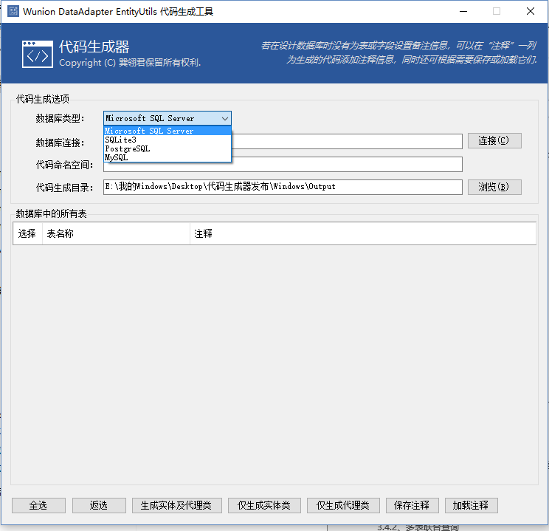

3.5.2: Cross-platform command line code generator
After extracting WdaEntityGenerator.zip in the Cross-platform folder, the language environment of the command-line code generator supports Simplified Chinese and English. Before running the command line code generator, you first need to install the .NET Core SDK on Linux or Mac OS X, see the Microsoft Official Web site: https://www.microsoft.com/net/download/linux/build The following example describes the use of the command-line code generator with Ubuntu Linux.

- Use the "cd" command to enter the directory where the code was born:
cd /home/cnzhnet/Cross-platform
- Execute command: dotnet ./WadEntityGenerator.dll en-US
or dotnet ./WadEntityGenerator.dll zh-CN
en-US for the English language environment, zh-CN for the Simplified Chinese language environment, the following figure:
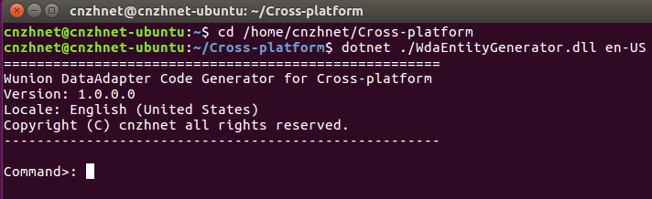
- Execute the "help" or "–h" command to view all of the commands supported by this tool and their assistance information
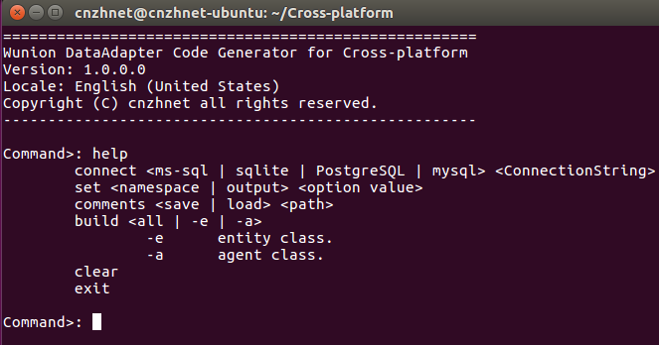
- Execute "connect" command connect to the given target database, the "connect" command has two parameter options, the first parameter is the target database type, and the supported database types are listed below:
ms-sql Represents a Microsoft SQL Server database
sqlite Represents a SQLite database
PostgreSQL Represents a PostgreSQL database
mysql Represents a MySQL database

The following command takes Microsoft SQL Server for example:
connect ms-sql Server=192.168.1.9;Database=Demo;User ID=sa;Password=******
After successfully connecting to the database, the following figure:
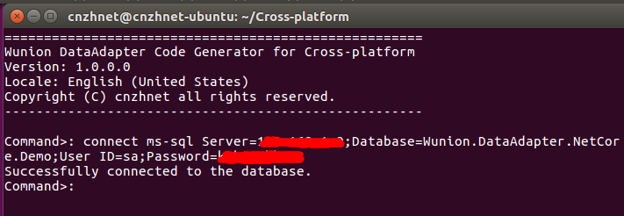
If the connection is not successful, an error message is printed.
- Execute command "set" to set the namespace used by the generated code:
set namespace Ling.TestCode.Entities
- Execute command "set" to set the build path of the code:
set output /home/cnzhnet/CodeOutput
- Execute command "build" generating code, and "build" command has an option. Values are: "all" or "–e" or "–a"
all means to generate entity classes and agent classes; -e means to generate only entity classes; -a means to generate the agent class and the context class;
Execution: "Build all" effect as shown below:
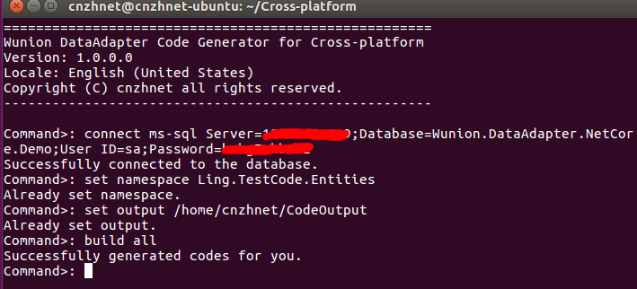

- If you do not add descriptive information to the tables, and their fields in the database when you create the database, the generated entity classes do not have code comments. At you can generate an XML code comment document by using the "comments" command, and then use the gedit or Nano editor to annotate tables and fields. Note: when the document edits are finished saving it. Use the "comments" command again to load the comments information for the code to be generated. If you already have comments or do not need code comments, the work generated by this code is finished, and you get all the code you generate in the output directory, without having to continue with all the steps that follow.

- Execute command to generate a comment document:
comments save /home/cnzhnet/CodeOutput/code_comments.xml
- Open the comments document for editing in the new terminal:
nano /home/cnzhnet/CodeOutput/code_comments.xml

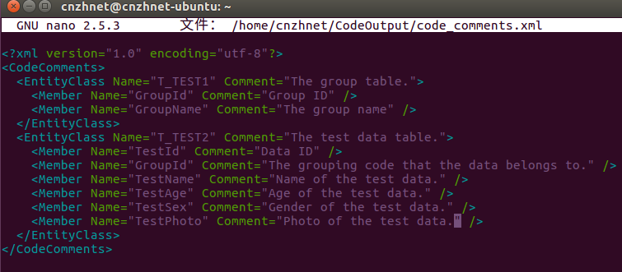

- Execute command load the code comments:
comments load /home/cnzhnet/CodeOutput/code_comments.xml
- Regenerate the code in step 7th by executing the "build" command (no need to delete the last generated code, the generator will automatically overwrite)

To verify that the generated code is executable: The file in the "ls" command list output directory, and open any one of the code files to view
